PROJECT TITLE
SpendWise – A Simple Backend Learning Project using Node.js, Express, MongoDB, and JWT
Project Overview
SpendWise is a backend-focused learning project designed to help beginner developers understand how real-world backend systems work. The project demonstrates how to build secure REST APIs using Node.js, Express, MongoDB, and JWT authentication.
This project focuses on implementing user authentication and basic CRUD operations in a clean and structured way so learners can understand the flow of backend development.
SpendWise acts as a simple backend system where users can register, log in securely, and manage their transactions.

Key Objectives
The main objectives of the SpendWise project are:
* Implement secure user authentication using JWT
* Build REST APIs using Node.js and Express
* Perform CRUD operations on transactions
* Demonstrate MongoDB integration using Mongoose
* Show how protected routes work using middleware
* Maintain a simple and beginner-friendly backend architecture

Target users
This project is designed for:
* Beginner backend developers
* Students learning Node.js and Express
* Freshers preparing for technical interviews
* Developers who want to understand JWT authentication
* Learners who want hands-on practice with REST APIs
Project Instructions
SpendWise is a backend-only project built using Node.js and Express.
Quick Start
Bash
Copy code
npm init
npm install
npm run dev

Steps to Create the Project
Create or choose a directory for the backend project.
Open the terminal and navigate to the project folder.
Initialize the Node.js project using:
npm init

Install required packages:
Express,
Mongoose,
Jsonwebtoken,
Bcrypt,
Cors,
Dotenv.

Create the following folders:
Models,
Routes,
Controllers,
Middleware,
Config.

Start the backend server:
npm run dev
Test APIs using Postman or Thunder Client at:
http://localhost:5000

Pre-Requisites
Software Requirements

Software Purpose
Node.js JavaScript runtime for backend
MongoDB NoSQL database for data storage
npm Package manager
Git Version control system
Code Editor Code or similar

Knowledge Requirements
● JavaScript ES6+
● Node.js and Express.js
● MongoDB and Mongoose
● JWT authentication
● Basic REST API concepts
● Git basics

Thumbnail for Project
● A simple backend project thumbnail representing:
Node.js + Express + MongoDB + JWT + CRUD APIs

Project Architecture
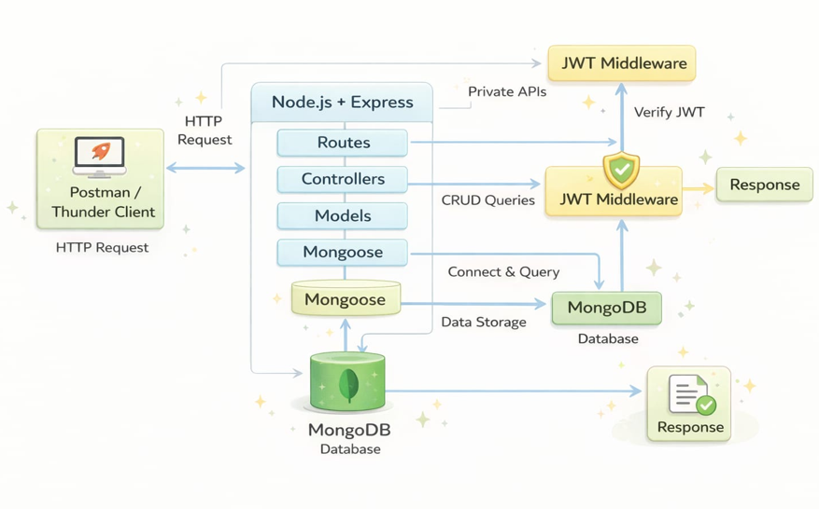
Technical Architecture
Backend Architecture (Node.js + Express)
● Controllers: Handle business logic for authentication and CRUD
● Models: Mongoose schemas for User and Transaction
● Routes: API endpoints for auth and CRUD operations
● Middleware: JWT verification and request protection
● Configuration: Database connection and environment variables

Database Architecture (MongoDB)
● Users Collection:
_id, name, email, password (hashed), createdAt
● Transactions Collection:
_id, userId (FK), title/description, amount/value, createdAt
● Relationship:
Many Transactions belong to One User

ER Diagram
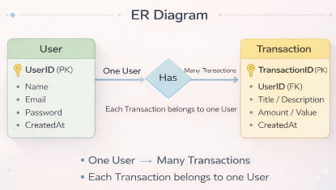

Features
No Feature Description

- User Authentication Secure registration and login using JWT
- CRUD Operations Create, Read, Update, Delete transactions
- Protected Routes Secure APIs secured using JWT middleware
- MongoDB Integration Data stored and retrieved using Mongoose

Roles and Responsibilities
Student / Developer
* Write backend code
* Create API endpoints
* Test APIs using Postman or Thunder Client
* Push code to GitHub
Backend System
* Authenticate users using JWT
* Handle CRUD operations
* Store and retrieve data from MongoDB
* Protect private routes using middleware
Project Setup and Configuration
Folder Structure
Example structure:
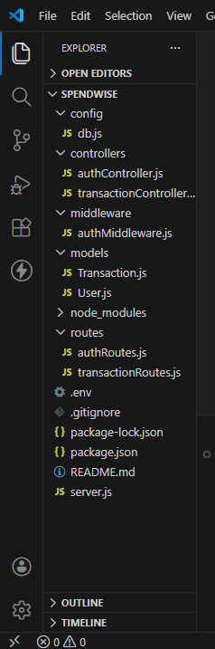

Backend Development
Setup Express Server
Create a server.js file.
Environment Variables
Create a .env file and define:

PORT=5000
MONGO_URI=your_database_url
JWT_SECRET=your_secret_key
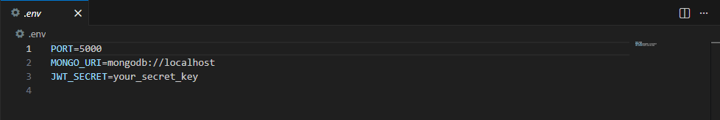

Configure Middleware
Use the following middleware:
* cors()
* express.json()
User Authentication
Implement:
* Register API
* Login API
JWT token will be generated during login.
Protected Routes
Use middleware to verify the JWT token before accessing protected APIs.
API Routes
Two main route groups:
Auth Routes
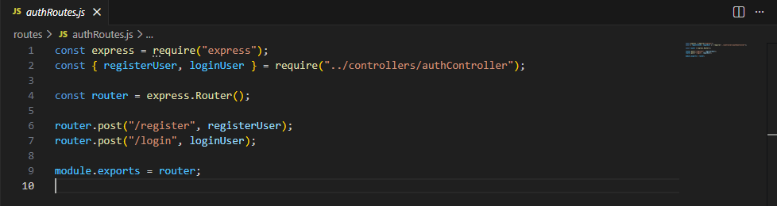

POST /api/auth/register
POST /api/auth/login

Transaction Routes
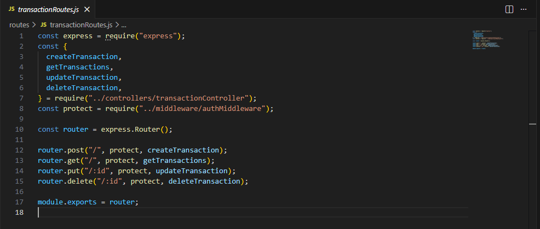
POST /api/transactions
GET /api/transactions
PUT /api/transactions/:id
DELETE /api/transactions/:id

Data Models
User Model
Fields:
* name
* email
* password
Password is hashed using bcrypt before storing.
Transaction Model
Fields:
* userId
* title / description
* amount / value
* timestamps

CRUD Operations
SpendWise supports the following operations:
Create – Add a new transaction
Read – Retrieve all user transactions
Update – Modify transaction details
Delete – Remove a transaction
All transaction APIs are protected using JWT authentication.

Database Development
Configure MongoDB
The project can use:
* MongoDB Atlas (Cloud)
or
* Local MongoDB
Database URL is stored in the .env file.
Database Connection
Create a config file to connect MongoDB using Mongoose.

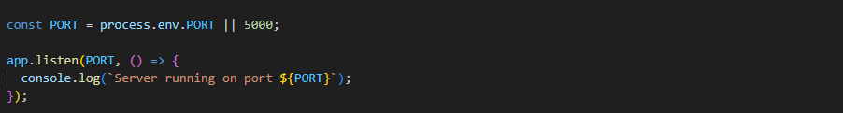
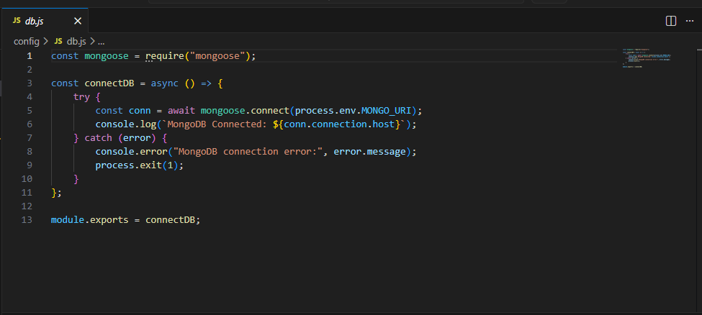

mongoose.connect(DB_URL)
Handle:
* Successful connection
* Connection errors

Project Execution
Follow these steps to run the project.
Step 1
Start MongoDB.
Step 2
Run the backend server.
npm run dev
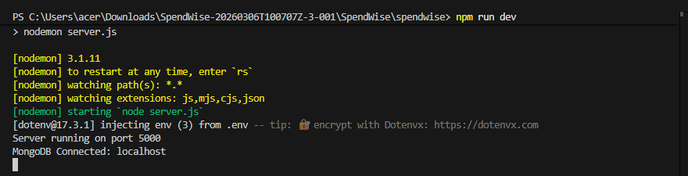

Step 3
Test Register API.
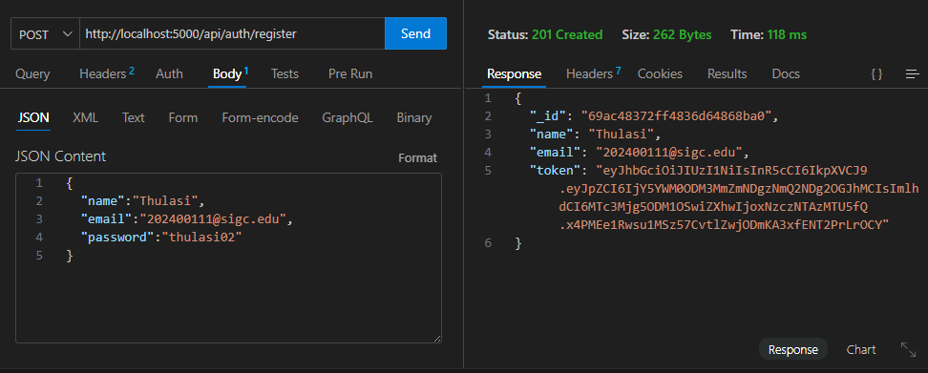

Step 4
Test Login API.
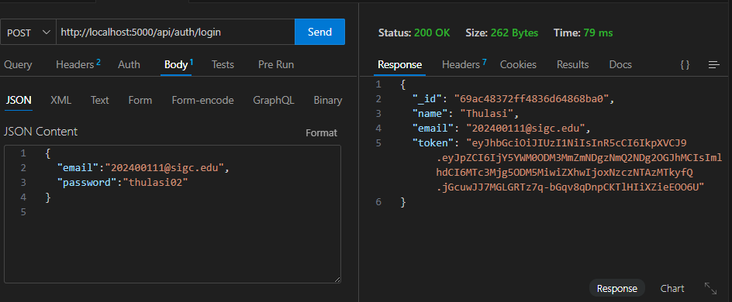

Step 5
Copy the generated JWT Token.

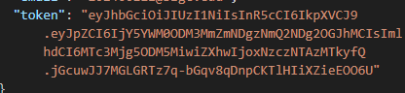
Step 6
Use the token to access protected CRUD APIs.

Step 7
Perform:
* Create transaction
* View transactions
* Update transaction
* Delete transaction

Output Screenshots
The project demonstrates the following API outputs:
Register API
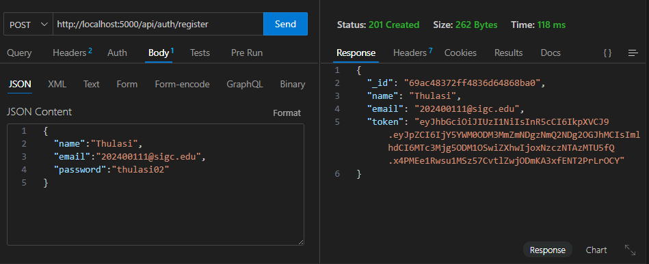
Login API
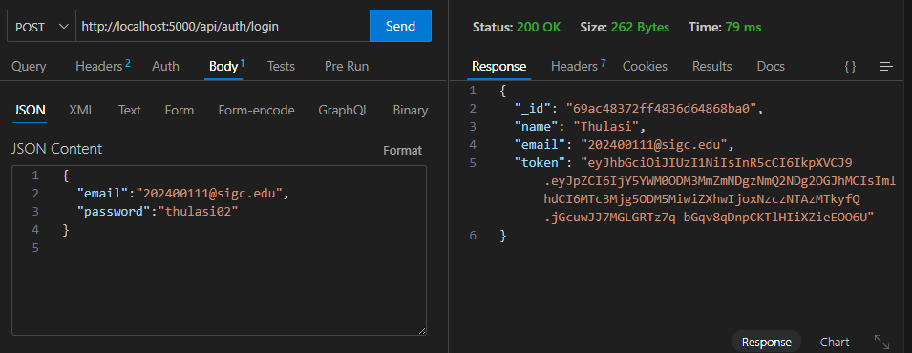

Create Transaction
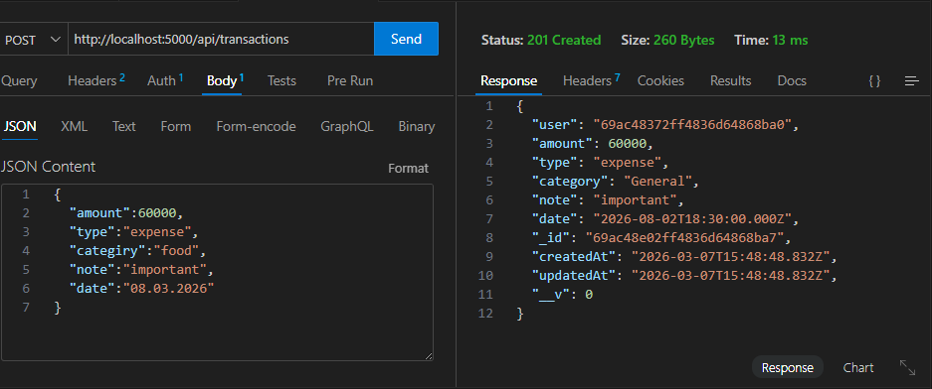

Get Transactions
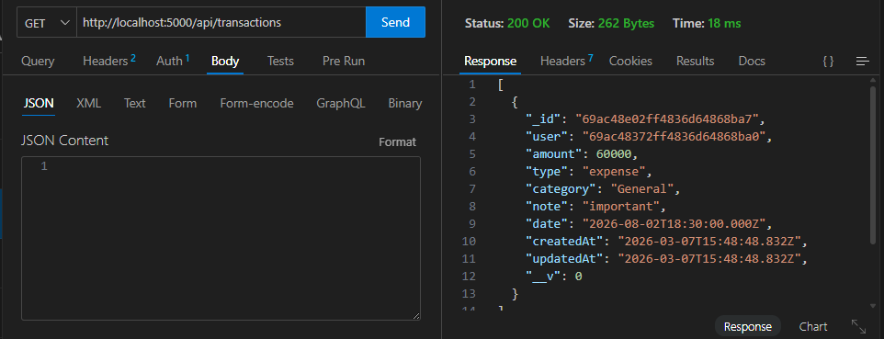
Update Transaction
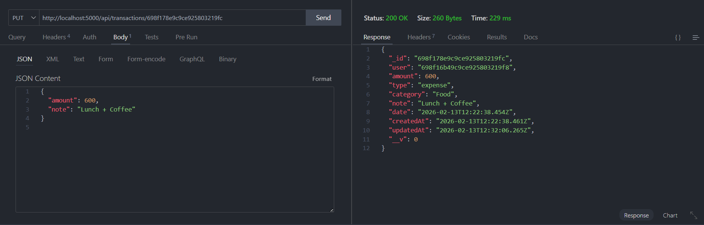

Delete Transaction
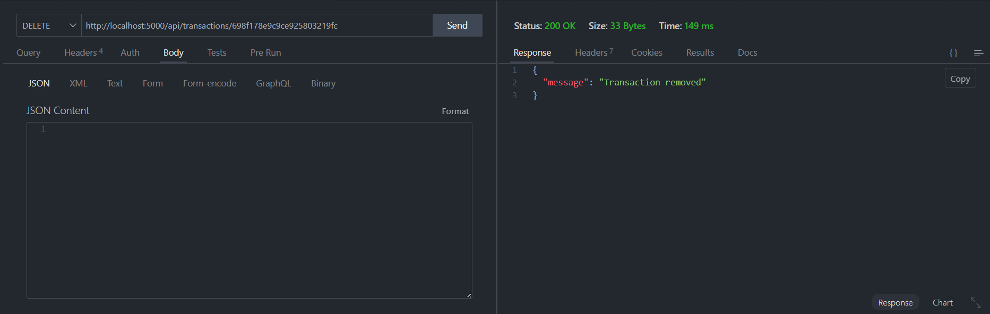

Project Demo Video
Project demonstration video:
https://drive.google.com/file/d/1lZxM3c42LSwZ36Bll-OKRa7di3CrbS8H/view?usp=drive_link
Drive Link:
https://drive.google.com/drive/folders/1Lzd33R53YKJ4ToiVI215BzNwhQ5pZpcm?usp=drive_link

